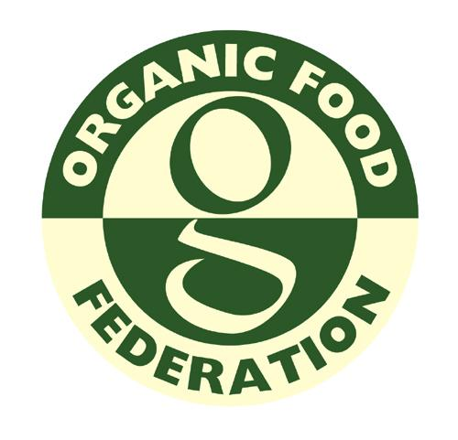

Organic Food Federation

CERTIFICATION AGREEMENT FORM FOR RETAIL AND FOODSERVICE OPERATIONS

THIS FORM MUST BE SIGNED AND DATED

Please email or post to the Organic Food Federation
31 Turbine Way, Eco Tech Business Park, Swaffham, Norfolk PE37 7XD
Tel: 01760 720444 Fax: 01760 720790
Email: info@orgfoodfed.com Web: www.orgfoodfed.com

- Company details

Please fill in all sections of the form, if not relevant please fill in N/A

Name of company:Click or tap here to enter text.
Trading name (if different):Click or tap here to enter text.

Companies House Number: :Click or tap here to enter text.
Ultimate holding company (if any):Click or tap here to enter text.

Function within ultimate company (if any): Click or tap here to enter text.
Name and address of premises to be registered:
Click or tap here to enter text.
Tel:Click or tap here to enter text.  Email:Click or tap here to enter text. | Mobile:Click or tap here to enter text.
Address for correspondence (if different):
Click or tap here to enter text.
Tel:Click or tap here to enter text. | Email:Click or tap here to enter text.
Name of person responsible for organic operations: Click or tap here to enter text.
Name of Chief Executive (if different):Click or tap here to enter text.
Annual turnover £Click or tap here to enter text. | Financial year: Click or tap here to enter text.
Number of staff involved with organic operations?
 |  | YES | NO
Have you been certified by another organic certification body?
If yes, what body?Click or tap here to enter text.
When did certification cease?Click or tap to enter a date.
Have you been refused certification by another certification body?
If yes, what body?Click or tap here to enter text.
Have there been any prosecutions within the last 12 months or pending which could affect organic certification?
If yes, provide a full explanation on a separate sheet.
If you are moving certification body have you contacted your present certifier to request that they forward your files to OFF

Note: The Federation reserves the right to contact DEFRA about any previous organic activities
- List products to be covered by organic certification

- Are these products

 | YES | NO
a) Consumed on the premises?
b) Consumed elsewhere?

- List the ingredients purchased for use in the above products:

Raw Material/Ingredient | Unit of purchase | Supplier | Certified by

 | YES | NO
Do you have a separate store or storage facility dedicated for organic materials and pre prepared food?
Do you plan to have dedicated preparation equipment for organic foods?
Please describe the facilities for food storage and preparation:
What measures are taken during food preparation to ensure that organic materials or work in progress are protected from accidental contamination or substitution?
What measures are taken at the point of sale to ensure that organic foodstuffs are kept physically separated from non-organic food?
If commodities and produce are presented for self-service, what precautions will be taken to ensure that organic commodities and produce are protected from contamination?
What packing materials are used for organic goods dispensed at the counter or by self-service, and how will they be labelled to show that the contents are organic?
How do you propose to account for the quantities of organic materials purchased and the quantity of organic foods that are sold? What records are kept?

Certification Agreement

Should you be accepted in to our organic certification scheme you are required to undertake to comply with the following:

- All relevant sections of our organic Standard at all times (as amended from time to time), including non organic requirements (covering reports, fees, access, confidentiality, exchange of information etc.).

- Prompt payment of all fees and charges including fees or costs for work undertaken for applications that do not proceed.

- Resolve any non compliance raised against your operation within the agreed timescale.

- Provide site access during normal working hours to inspectors authorised by us, with or without prior notice, for the purpose of carrying out surveillance inspections or collection of samples from operations, which are subject to a certificate of conformity.

- Agree, if accepted into our certification scheme, to give three months notice in the event of wishing to withdraw from the scheme, unless due to circumstances beyond your control.

- Inform the Federation of all intended changes to the process and the processing environment. This includes legal and commercial; organisational status of ownership; key management changes; modifications to product or production method; contact address and production sites and major changes to the quality management system.

- Provide true and correct statements on the certification agreement form.

Signed:
Print Name:
Company:
Position:
Date:

(This section must be completed in order to proceed with the assessment inspection.)

NOTE: We are asked from time to time to provide lists of organic operators to third parties seeking suppliers or potential customers. Please indicate if you do NOT wish your company to be included on any such lists by ticking the box.
Office Use only

Date Received:
Additional Info required:
Previous CB:
Papers from Previous CB:
Accepted and Quoted:
Quotation accepted:
Reference No:
Logged on:
Date Assigned:

