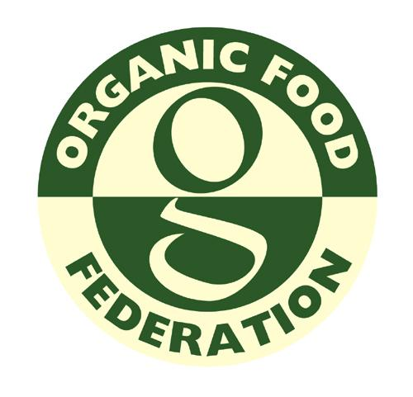

Organic Food Federation

CERTIFICATION AGREEMENT FORM FOR PRODUCERS

AGRICULTURE
HORTICULTURE
LIVESTOCK
AQUACULTURE

THIS FORM MUST BE SIGNED AND DATED

Please email or post to the Organic Food Federation
31 Turbine Way, Eco Tech Business Park, Swaffham, Norfolk PE37 7XD
Tel: 01760 720444 Fax: 01760 720790
Email: info@orgfoodfed.com Web: www.orgfoodfed.com

- Company details
Please fill in all sections of the forms if not relevant please fill in N/A

Name of company:Click or tap here to enter text.
Trading name (if different):Click or tap here to enter text.
Companies House Number: Click or tap here to enter text.
Ultimate holding company (if any):Click or tap here to enter text.
Function within ultimate company (if any): Click or tap here to enter text.
Name and address of premises to be registered:
Click or tap here to enter text.
Tel:Click or tap here to enter text.  Email:Click or tap here to enter text. | Mobile:Click or tap here to enter text.
Address for correspondence (if different):
Click or tap here to enter text.
CPH Number: Click here to enter text..
Tel:Click or tap here to enter text. | Email:Click or tap here to enter text.
Name of person responsible for organic operations: Click or tap here to enter text.
Name of Chief Executive (if different):Click or tap here to enter text.
Annual turnover £Click or tap here to enter text. | Financial year: Click or tap here to enter text.
Number of staff involved with organic operations?
 |  | YES | NO
Have you been certified by another organic certification body?
If yes, what body?Click or tap here to enter text.
When did certification cease?Click or tap to enter a date.
Have you been refused certification by another certification body?
If yes, what body?Click or tap here to enter text.
Have there been any prosecutions within the last 12 months or pending which could affect organic certification?
If yes, provide a full explanation on a separate sheet.
If you are moving certification body have you contacted your present certifier to request that they forward your files to OFF

Note: The Federation reserves the right to contact DEFRA about any previous organic activities

2. List persons responsible for:

Area of Responsibility | Name | Contact Details
Environment Management
Collection
Toxicology (especially for fungi)

3. Map of holding/livestock areas/aquaculture sites

You must include a map showing the boundaries of the total holding outlined in blue, organic in green and in-transition in red, and the area of each of the fields and buildings.

4. Details of crops

IMPORTANT NOTES:

Transition 1 Entry point for conversion (mandatory for all organic crops)
Transition 2 2nd year conversion (mandatory of annuals & perennials)
Transition 3 3rd year conversion (mandatory for perennials)
Organic Land becomes organic after completion of 2 years conversion (annuals) and 3 years conversion (perennials)

LIST BELOW:

Hectarage to enter
Transition 1 | Transition 2*  (Annuals only) | Transition 3*  (Perennials only) |  | Organic* | Non Organic
*If land is going through transition or organic please enclose certificates

5. Field Schedule

Field Number | Hectarage | Current Crop

6. Conversion plan

If land is not already in conversion you must submit a written conversion plan prior to inspection. See 5.2.1 of the federation’s production standard.

7. Simultaneous Conversion

 | YES | NO
Will you be converting your land and livestock simultaneously?

8. Details of Livestock:

Organic Species | Numbers | Non-Organic Species | Numbers

Certification Agreement

Should you be accepted in to our organic certification scheme you are required to undertake to comply with the following:

- All relevant sections of our organic Standard at all times (as amended from time to time), including section 3 general non organic requirements (covering reports, fees, access, confidentiality, exchange of information etc.).

- Prompt payment of all fees and charges according to section 3.8 of our Standard including fees or costs for work undertaken for applications that do not proceed.

- Resolve any non compliance raised against your operation within the agreed timescale.

- Provide site access during normal working hours to inspectors authorised by us, with or without prior notice, for the purpose of carrying out surveillance inspections or collection of samples from operations, which are subject to a certificate of conformity.

- Agree, if accepted into our certification scheme, to give three months notice in the event of wishing to withdraw from the scheme, unless due to circumstances beyond your control.

- Inform the Federation of all intended changes to the process and the processing environment. This includes legal and commercial; organisational status of ownership; key management changes; modifications to product or production method; contact address and production sites and major changes to the quality management system.

- Provide true and correct statements on the certification agreement form.

Signed:
Print Name:
Company:
Position:
Date:

(This section must be completed in order to proceed with the assessment inspection.)

NOTE: We are asked from time to time to provide lists of organic operators to third parties seeking suppliers or potential customers. Please indicate if you DO wish your company to be included on any such lists by ticking the box.
Office Use only

Date Received:
Additional Info required:
Previous CB:
Papers from Previous CB:
Accepted and Quoted:
Quotation accepted:
Reference No:
Logged on:
Date Assigned:

